School payments online

Our school encourages families to pay for school expenses using the myKindo portal for paying accounts and purchasing shop items. It’s simple, open 24/7 and available at mykindo.co.nz, via the link in payment reminder emails or on our school website.

Creating an account (once only)

Getting started is fast & easy. Click here or on the link in your payment reminder emails. All you need is the email address the school has on file for you. Your account will be created and can be used for all students at any school.

You only need to register once. After that, log in with your email address and password at mykindo.co.nz – or use the link in the payment request emails. Any registered caregiver can create an account. If you already have an ezlunch or Kindo account, just log straight into mykindo.co.nz using your existing details. You may be prompted to link to Vauxhall school so that you can see your family’s personalised account and you can add a child to the school by selecting the ‘my details’ heading.

Selecting items to pay

There are TWO types of transactions you can make using myKindo: paying personalised payment requests for your students; purchasing optional items.

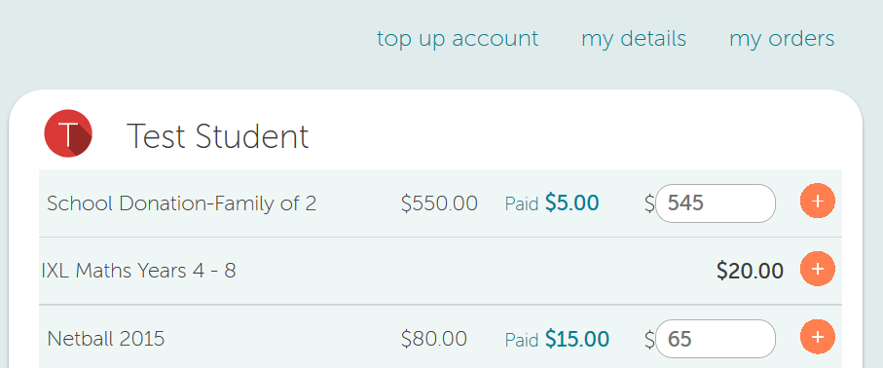
at the top of the screen are personalised payment requests under a student name. Pay the full amount by clicking ‘+’ next to the item or make a part payment, by changing the amount before clicking the ‘+’ (if available).
Once you have paid for something in full the item will be removed from your personalised account.

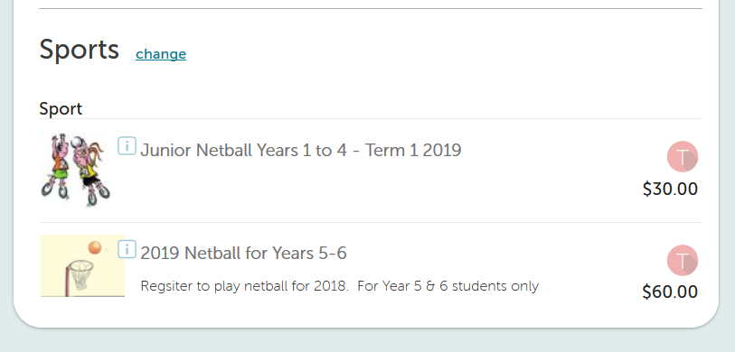
underneath are the shop/optional items. You can navigate quickly to more items using the services menu on the left of the screen. Click on your child’s initial next to an item to add to your cart.
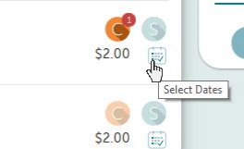
For a dated service (such as Lunch), select your first delivery date, then you can add items to the cart for that date, or click the calendar icon to add items to multiple dates.
Items will not be removed when bought, as these are generally ‘shop’ items. If you’re unsure, you can view order history on ‘my orders’.

Topping up your account

Add funds to your myKindo balance when paying at the checkout, or by selecting ‘top up account’ from the menu.

There are three methods available:

1. Bank Transfer (through your bank app)
No fees. IMPORTANT: Orders cannot be placed until funds are received. Allow 2 days.

2. POLi internet banking
No fees. Instant transfer, orders placed immediately.

3. Credit/Debit Card
50c + 2.5% fee. Instant transfer, orders placed immediately.
Visa / MasterCard / American Express / China UnionPay available.

Checkout & payment

Once you have finished adding items to your cart, click ‘Check out’ to review your order.

Click “Place Order’ to complete the transaction. If you do not have sufficient funds, the button will say ‘Top Up & Place Order’ and enable you to add funds (see “Topping up your accoung”).

Kindo will automatically update the school, and you will receive an email receipt confirming your payment and/or top-up.

Need assistance?

Please ask at the school office.

For technical assistance, go to support.mykindo.co.nz, email hello@mykindo.co.nz or call the Kindo helpdesk on freephone 0508 4 KINDO (0508 454 636). The helpdesk is open 8am - 4pm weekdays.

